Project: make a sign
Name: _______________

Direction:
We learned how to read sign and notice this week. Do you still remember the following?
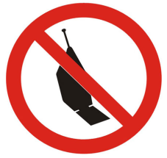
Now, let’s make a sign for our school, brainstorm the idea what is not proper for the school setting, like: sleeping in the class, running in the hall way, yelling in the cafeteria, jumping off the school bus, not doing HW, delaying project, missing the music rehearsal, lie to teachers and parents, cheating, bullying, plagiarizing, etc.
- draw a picture for what is prohibited in school
- write a Chinese subtitle
- Cut and paste the sign onto a cardboard paper or construction paper.
- Also, write a short notice in Chinese, to explain the sign you make.

NOTICE

_____________________________________________________________________

_____________________________________________________________________

_____________________________________________________________________

_____________________________________________________________________

_____________________________________________________________________

_____________________________________________________________________

