How to change the language setting on Windows XP http://www.youtube.com/watch?v=SqcYicz2cGg&feature=related
http://www.youtube.com/watch?v=DPeNAtwQMoI&feature=fvwrel

How to type Chinese on your Windows system

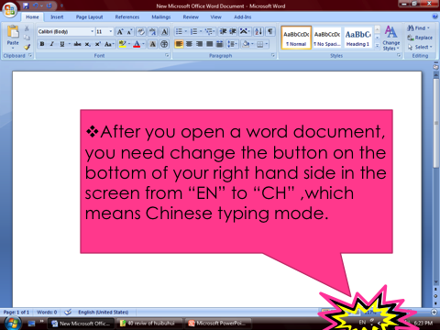
1. 2.

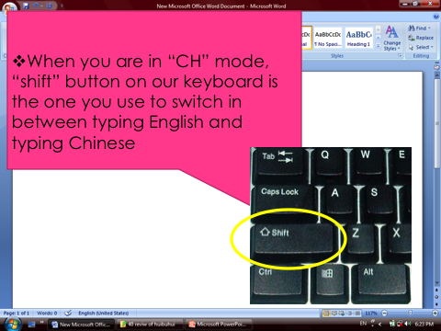
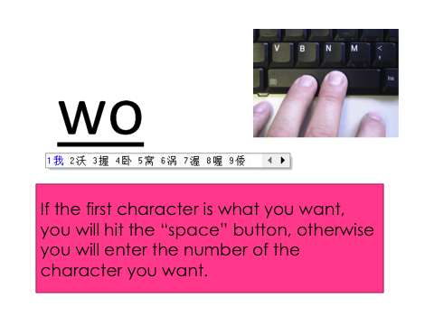

3. 4.

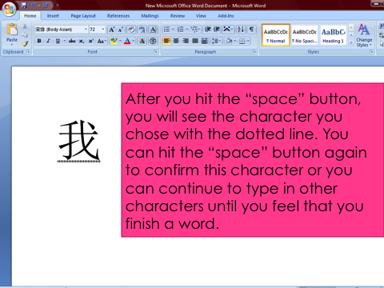

Practice typing Phrases

1.zhōng guó rén

2.ào dà lì yà ren

3.yīng guó

4.dé guó

5.Jiā ná dà

Please type the questions and your own answer

1. ni shi na guo ren?

2. Ni hui bu hui shuo han yu?

3. Ni you jige xiongdijiemei

4. Ni jia zhu zai nali

5. Ni xihuan zuo shenme gongzuo?

6. Ni youmeiyou biyou?

7. youchai zai nali gongzuo?

8. laoshi zai nali gongzuo?

9. yisheng zai nali gongzuo?

10. lvshi zai nali gongzuo?




