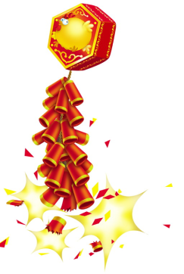
Chinese New Year Song
Xin Nian Hao

新年好呀, 新年好呀!
Xin nian hao ya, xin nian hao ya
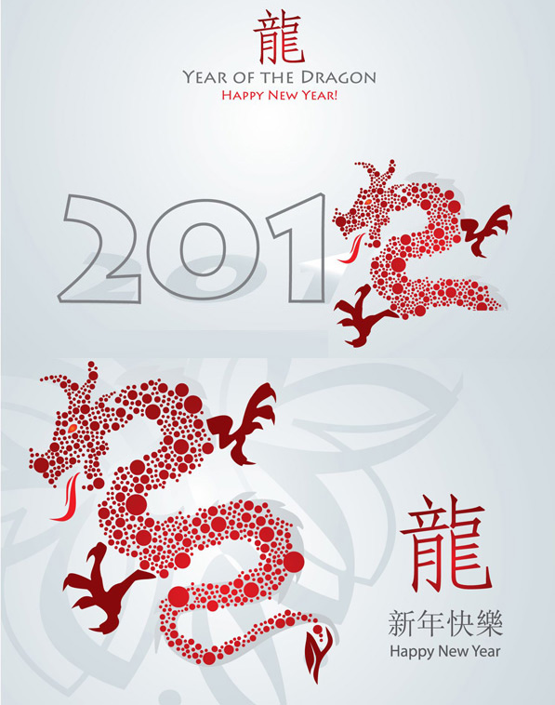
祝賀大家新年好!
Zhu he da jia xin nian hao
我們唱歌,我們跳舞,
women chang ge, women tiao wu
祝賀大家新年好!
Zhu he da jia xin nian hao

Step 1, Underline the character/phrases you know
Step 2, Circle the character/phrases which repeat more than once
Step3, Note the meaning of the new character/phrases
Step4, Figure out the meaning of the whole lyrics
Step5, sing!

